It is based on INFRARED SENSOR. A pair of IR LED and PHOTODIODE is used along with some other components to I had made a working model of a Door security alarm system. The basic working of my project finally create a sensor that senses objects. And simply by adding a buzzer to the IR sensor circuit, the door security alarm system was ready.

The components that are used in the project are: -

1. 1 IR LED PHOTODIODE PAIR
2. 1 LED
3. RESISTORS : 2*220kohm,1kohm
4. PCB
5. BATTERY (9V)
6. BUZZER
7. CONNECTING WIRES

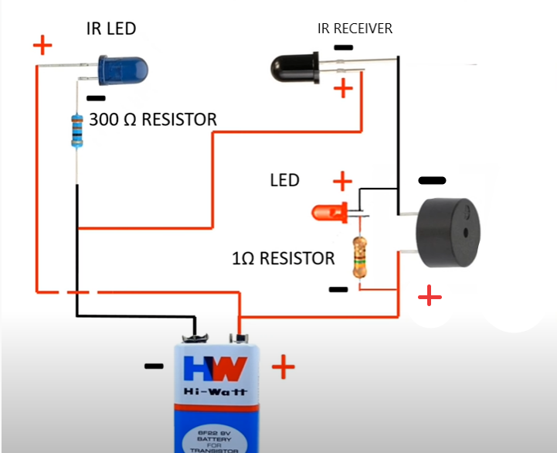

First of all when switch on the dc power supply then IR transmitter transmit the infrared rays and IR reciever recieves the rays from transmitter and thus circuit completes and buzzer makes sound and now when any obstacles comes in between the transmitter and receiver path although power supply is on then circuit is not complete and hence buzzer does not make sound . This system is installed on the door and corresponding to it a piece of wood(any object which break the path of transmitter and receiver) is placed on the wall of which main objective is to break the cicuit. In normal mode, door is closed and piece of wood is between transmitter and receiver and is breaking the circuit now when any thief or any person open the door then circuit breakes and buzzer makes sound . This is how the system prevents burglary and unauthorities invasion .